Specs for Autism & Gaze Toddlers pilot

THE LABORATORY TASKS

Two tasks with eye tracking and heart rate measurements will be run, intermixed together.

**Calibration**

First, the calibration is run

* Using ready-made Python script?
* Possibility to calibrate in between?

**The sequence of the blocks:**

A block contains 3 trials of Playing Lady task or 2 trials of Orientation task. Every block is repeated 6 times.

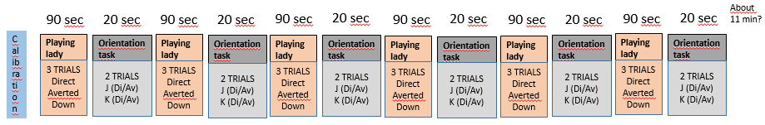

The order of the trials is pseudorandomized within each block (see details under the tasks).

The Playing lady –task is always presented first (Or the order is counterbalanced between the participants)?

**Acquiring the heart rate data**

The heart rate recordings are made with Netstation, running on a separate Mac computer. The script sends events to the netstation (described below under the tasks).

**Acquiring the eye tracker data**

The pc-computer running the tasks also collects the eye tracking data. The events that are written to the data as described below under the tasks.

**Online monitoring**

The gaze of the child (eye tracker data) is monitored online (IF POSSIBLE!). A video camera, positioned on the top of the screen, films the childs’ face and a mirror behind the child. This is monitored and recorded with Netstation MAC computer.

**TASK 1: *Orientation task***

This task is the same than in previous Autism & Gaze –project, coded previously with matlab. See picture below. The HR orienting response will be measured to the gaze shift as reference to the face with downcast gaze.

The sequence of a trial:

* The trial starts with a key press by experimenter. An animated attention grabber appears to the screen, same level as the eyes are in the next face picture. 🡪 Event “AG” (Attention Grabber) to the Netstation and gazedata

The next picture is launched by gaze contingency function (minimum duration of fixation?) when the child looks at the attention grabber. It can be launched by experimenter as well as a backup.

* A head, slightly turned to the left or right, with a downward gaze will appear on the screen after an attention grabber 🡪 Event “DoKr” (Down Karoliina right) / “DoKl” / “DoJr” / “DoJl” to the Netstation and gazedata

Duration 2 s.

* The next picture, where the gaze will shift up, either towards the camera (direct) or towards the same direction as the head orientation appears (averted) 🡪 Event “DiKr” (Direct Karoliina right)/ “DiKl” / “DiJr” / “DiJl” / “AvKr” (Averted Karoliina Right) / “AvKl” / “AvJr” / “AvJl” to the Netstation and gazedata

Duration 3 s.

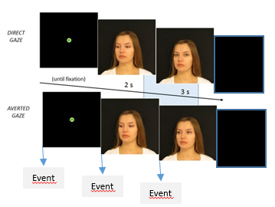

This task is the same as in the previous Autism & Gaze project, expect that there is no task after the trial. Between the trials, there is a black screen, waiting for the key press, which launches the next trial. Background music is might to be added? It might be, that it would be good to add a short animation between each trial; however, let’s first pilot without.

The stimuli includes 2 different identities of faces (Karoliina “K”, Jerita “J”), with two different gaze conditions (direct, averted), which makes four different kind of trials. Each of the two faces are presented once in each block. The order of the gaze conditions is pseudorandomized, different, premade order for each participant.

SUMMARY OF TRIALS:

6 direct (3 Jerita, 3 Karoliina)

6 averted: (3 right , 3 left ; 3 Jerita, 3 Karoliina

Randomization rules:

* K starts the block in 3 blocks, J in 3 blocks
* Direct gaze first in 3 blocks, Averted in 3 blocks
* For Averted gaze, 3 to the left and 3 to the right in total
* For half of the participants, the direct gaze is first in the first block, for half, averted.
* The same gaze condition first in maximum of 2 block in a row
* In the same block there can be two same gaze directions, but max 4 times in each participants.
* *Terhi will create the pseudorandomization.*

***TASK 2: The playing lady***

In the *playing lady task,* the infants will be shown a person who is repeatedly pushing a toy car down from a slide (or playing repetitively with another toy). After a few repetitions, the person will pause the action (🡪 event). Once the toddler turn her/his gaze towards the face of the person (->event to the Netstation and gaze data) , she will do randomly one of the gaze conditions: 1) turn her gaze directly to the camera 2) turn her gaze to the side of the table towards a box (left or right) 3) lifting her head a bit without turning her gaze. (🡪 event when the second video is started). After this, she will smile, do an action with her hand, and continue playing. See the picture below about the sequence of a trial. In between of the trials, there is a black screen, until the key press. The 3 trials with these 3 gaze conditions are played in each block in pseudorandomized order.

Exceptions:

* if the child does not look at the face AOI within 5 seconds, trials continues
* How could we know online whether the trial continues without the gaze in AOI? E.G. text to the experimenters screen?
* Could we export a trial (with some keyboard key) during the first part of the video, so that it will be played from beginning after a pause? (In a case of emergency, tantrum etc)
* While waiting fixation: launcing by the hand by experimenter should be possible in the case of malfunction of the eye tracker.

The sequence of a trial:

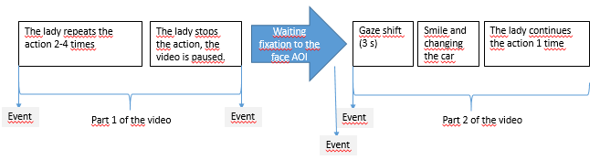

Events:

* Event 1: Lsta (Lady starts playing)
* Event 2: Lpau (Lady pauses the action)
* Event 3: FAOI (Fixation to face AOI)
* Event 4: Di1r (Direct, slide 1, right) / Di1l / Av1r (Averted, slide 1, right) / Av1l / Do1r (Down, slide 1, right) / Do1r / Di2l / Di2r / Av2r / Av2l / Do2r / Do2l

Randomization rules (Terhi will create the pseudorandomization…)

* (ensuring, that every gaze condition is played twice as the first one in the block).